# Example 1

Process for making a new web map, adding layers from Living Atlas, and creating a dashboard app.

1. Sign in to ArcGIS Online at <https://arcgis.com>.
2. In the top navigation menu, click **Map** to open a new, untitled web map.
3. Save the new map by clicking **Save and open 🡪 Save as** in the left-side menu.  
   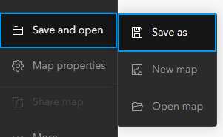  
   Enter the following title, tags, and summary when saving the map:  
   **title –** Air Quality Conditions Name Initial (for example-Y.I.)  
   **tags –** air quality, global  
   **summary –** Web map for a simple dashboard that will display current air quality conditions around the world.
4. In the left-side menu, select **Layers**. Click **Add** in the **Layers** pane that appears.  
   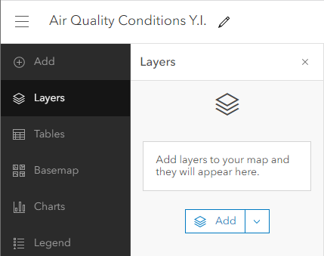
5. Click **My Content** and select **Living Atlas** from the drop-down menu. You can now search for Living Atlas layers and add them to your map.
6. Search for **air quality**. The top result should be **Recent Conditions in Air Quality** by **Esri**. Click the **plus** symbol to add the layer to your map.  
   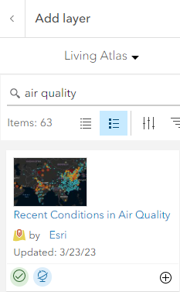  
     
   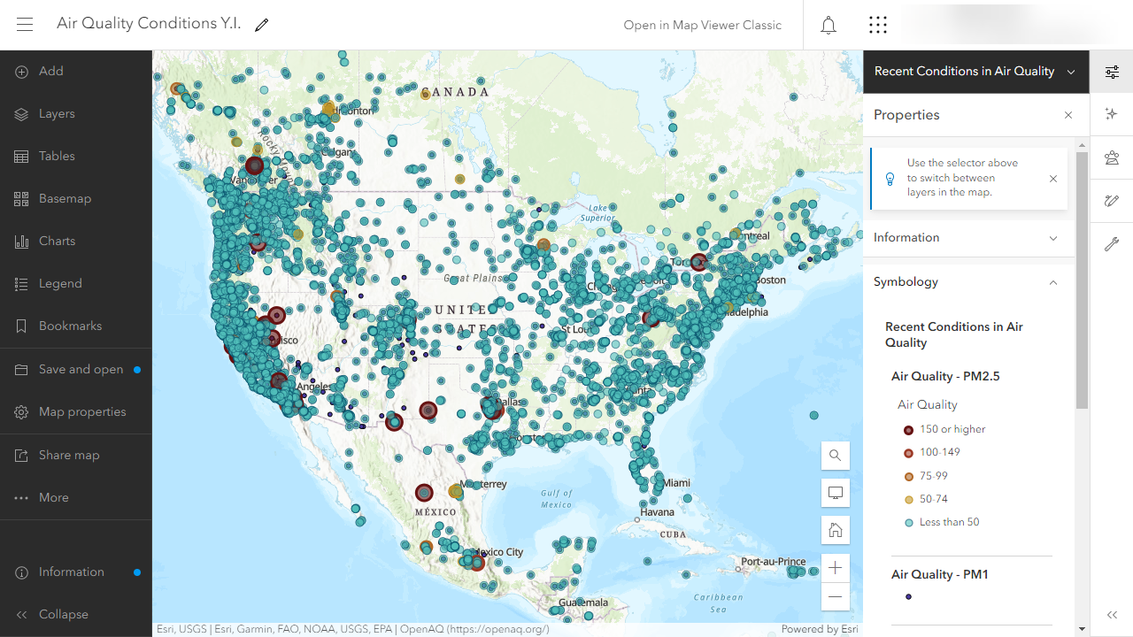
7. **Save** the map.
8. In the left-side menu, click **… More** and select **Create app**. In the window that appears, click **Dashboards**.  
   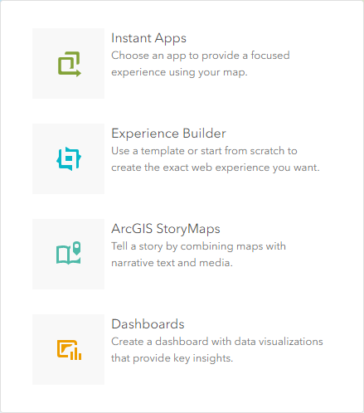
9. Enter the following information on the **Create new dashboard** page:  
   **title –** Air Quality Conditions Dashboard Your.Initials.  
   **tags –** air quality, global, dashboard  
   **summary –** A simple dashboard for displaying current air quality conditions around the world.  
     
   Click **Create dashboard** after entering the above information.
10. You are now working in the dashboard editor.  
    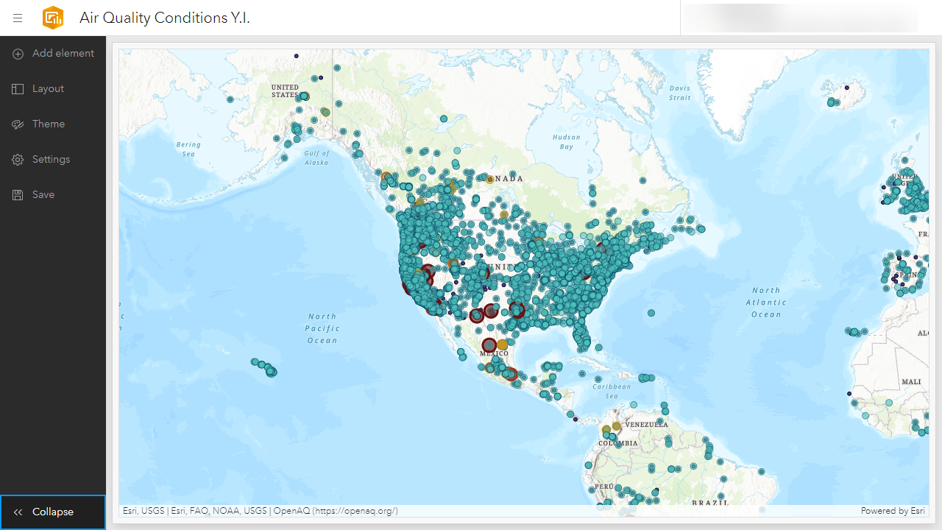
11. Click **Add element** at the top of the left-side menu.
12. Four plus symbols will appear on the map: top, right, bottom, and left. Click the bottom plus symbol.  
    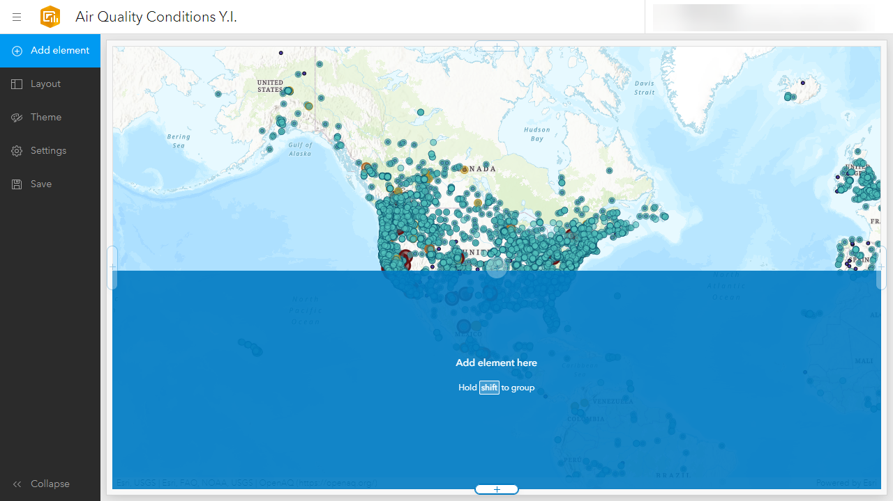
13. Select **Table** from the menu that appears.
14. On the **Select a layer** window, expand **Recent Conditions in Air Quality**. There are three different layers to choose from. Select **Air Quality – PM2.5**.
15. On the **Table** window, switch the **Table type** from grouped values to **features**.   
      
    Use **Add field** to add the following fields to the table: Country, Location, Value – mass concentration, Unit – mass concentration, and Last updated.  
    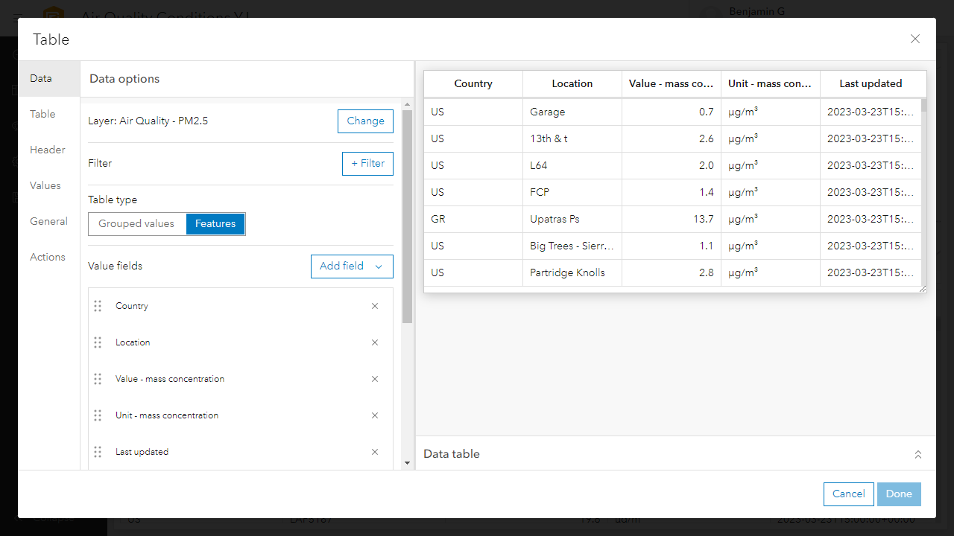
16. Switch to the **Table** tab on the left-side of the **Table** window. Complete the following actions:
    1. Toggle on **Row striping**. This will alternate the background color between each row.
    2. Toggle on **Hover text**. This will allow the user to hover over an item in the table with their mouse cursor and view its full text in the event it is truncated.
17. Switch to the **Header** tab on the left-side of the **Table** window. Complete the following actions:
    1. Change the **text color** to the hex value: FFFFFF
    2. Change the **background color** to the hex value: 8E6F3E
    3. Change the **rule color** to the hex value: 9D9795
18. Switch to the **General** tab on the left-side of the **Table** window. Complete the following actions:
    1. Click **Edit** next to **Title** and enter: **Air Quality – PM2.5**
    2. Click **Edit** next to **Description** and enter: This table displays attributes from the Air Quality - PM2.5 layer.
19. Switch to the **Actions** tab on the left-side the **Table** window. With the **selection mode** set to **single**, toggle on **Air Quality Conditions Y.I** for the following actions: **Flash, Pan,** and **Zoom**.This will cause the map to pan and zoom to the location of the point feature associated with a record when it is clicked in the table. The point feature will also temporarily flash drawing the viewer’s attention.  
    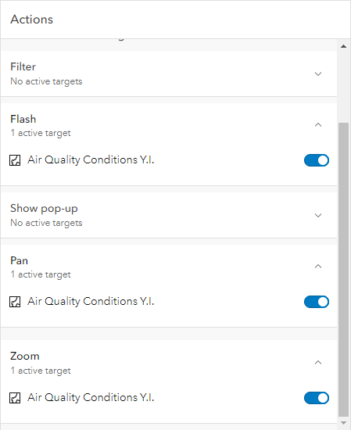
20. Click **Done** to finish editing the table. Try clicking on a record and verifying the actions are working properly.
21. Save the dashboard.
22. Next you will add an indicator to the dashboard that displays the average PM2.5 mass concentration value.  
      
    Add an **Indicator** element to the top-left of the dashboard.  
    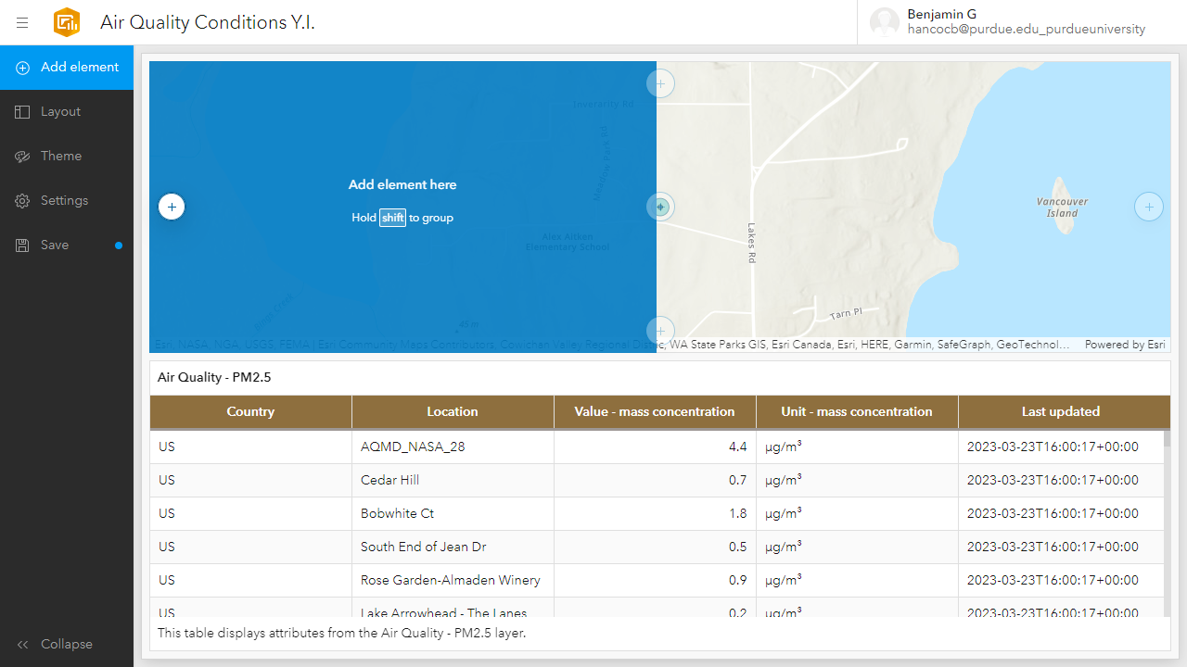
23. On the **Select a layer** window, select **Air Quality – PM2.5**.
24. Under **Data options 🡪 Settings**, select **Average** as the **statistic** and **Value – mass concentration** as the **field**.  
    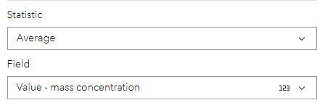
25. Next, click the **Filter** button. There are a few outliers with very high values influencing the average and we would like to filter them out. Select **Value – mass concentration** as the **field for the condition**. Change the condition from **between** to **less than or equal**. Enter **100** as the **value**.   
      
    At the time this guide was created, the indicator value dropped from 15.3 to 9.1 when the condition was established.
26. Switch to the **General** tab on the left-side of the **Indicator** window. Enter the following description: Average mass concentration reported in µg/m3.
27. Click **Done** to finish customizing the indicator.
28. Reduce the width of the indicator so it is only occupying roughly 25% of the map window.  
    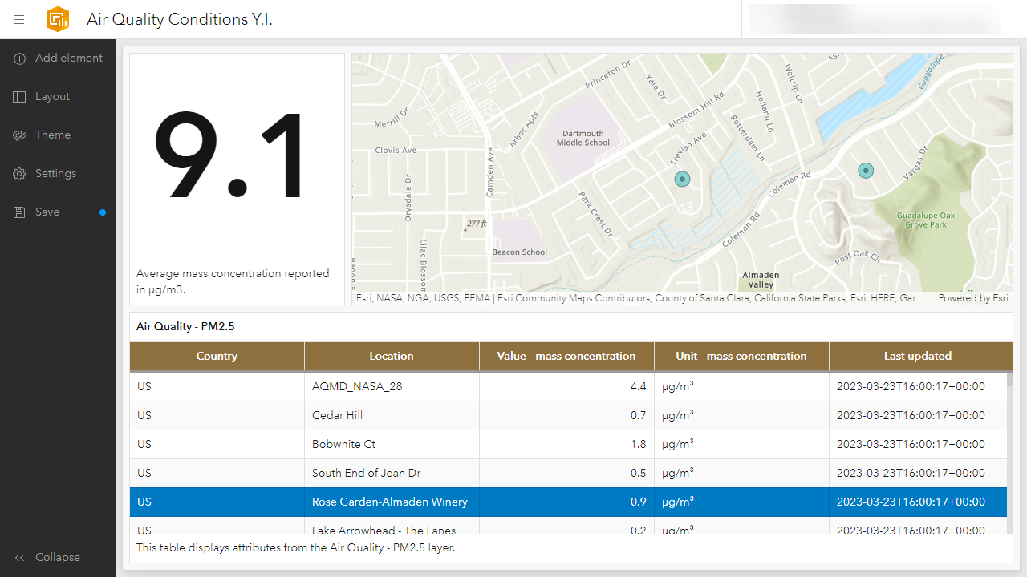
29. Save the dashboard.

# Example 2

Process for opening a layer from Living Atlas in a new web map and creating a dashboard app.

1. Navigate to Living Atlas of the World at <https://livingatlas.arcgis.com>.
2. Search for **osm traffic**. Find the **OSM – Traffic** item in the search results, click the more options button (**...**), and select **Open in Map Viewer**.  
   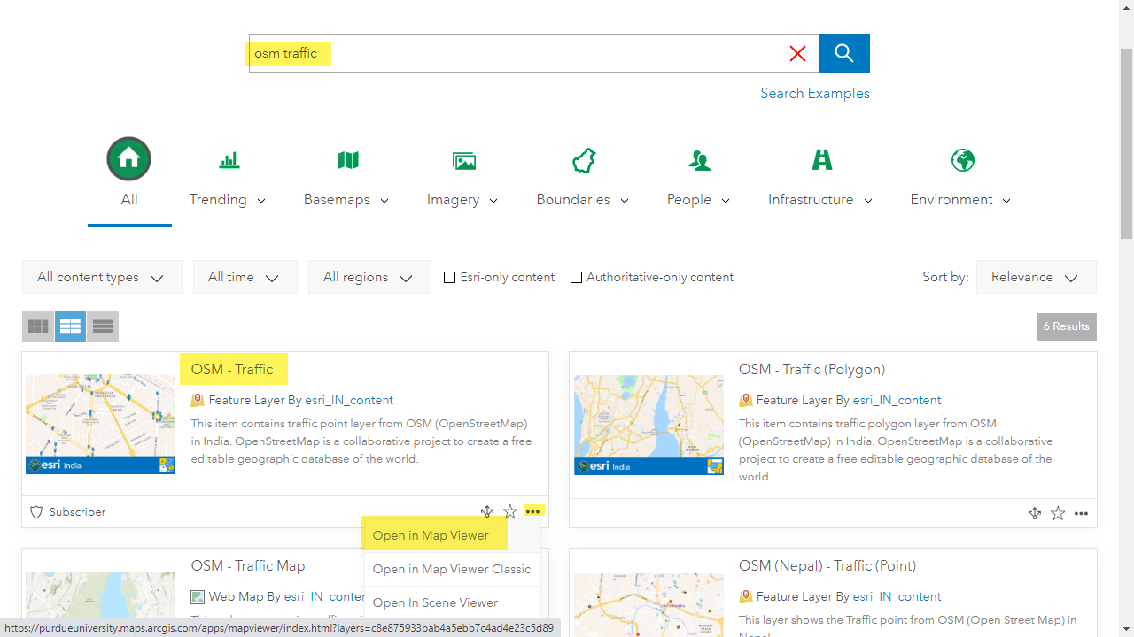
3. An untitled map featuring the dataset will be created. The map layer is displaying Open Street Map (OSM) traffic point data in India.  
   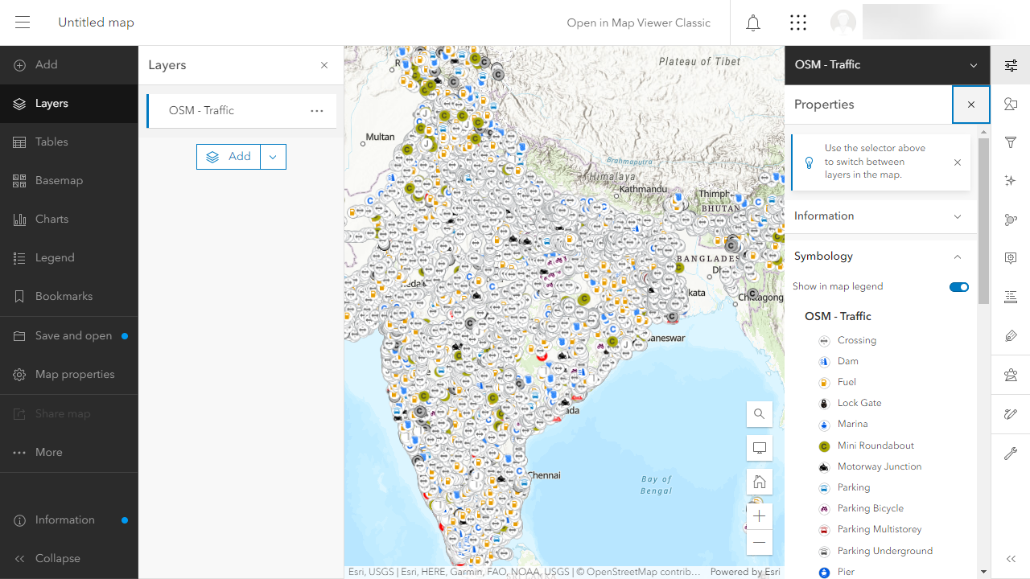
4. Save the map, providing a title, tags, and summary in the process.
5. Clicking on a point will cause a pop-up to appear.  
   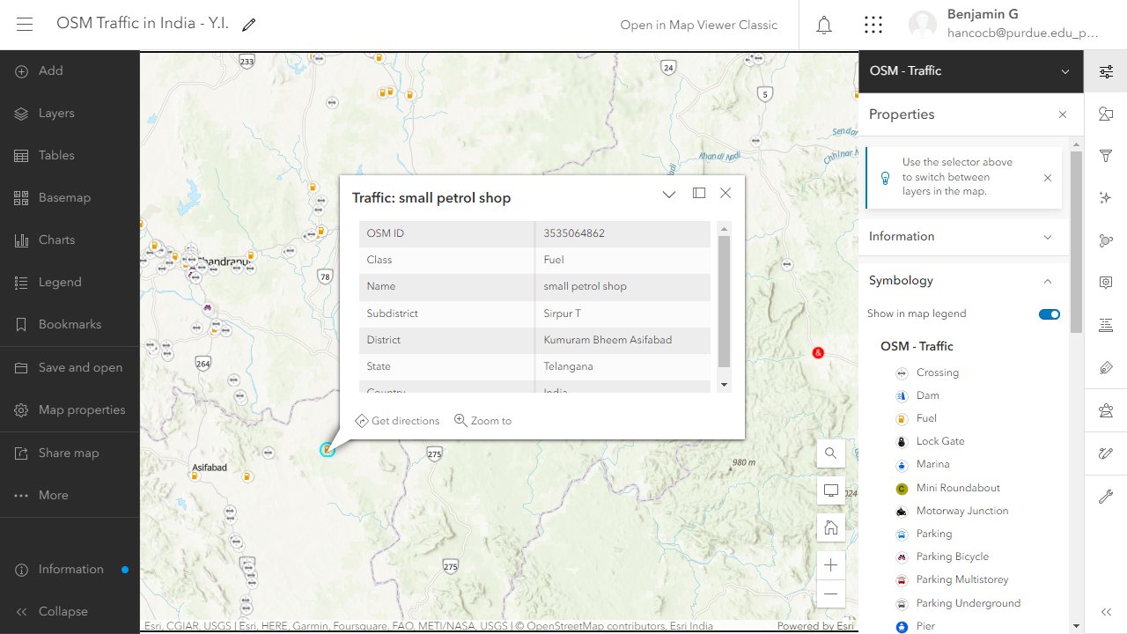  
     
   These pop-ups can be edited here in the web map. Later, when a dashboard is created from the web map, the pop-up changes will be carried over to the dashboard.
6. In the right-side menu, click the **Pop-ups** icon to open the **Pop-ups** pane.  
   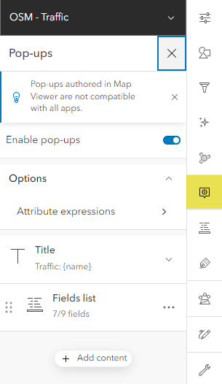
7. Currently the pop-up title displays the text “Traffic” followed by **{name}**. **{name}** refers to an attribute named **name**. When a point feature is clicked on the map, the attribute **value** in its **name** column will be displayed in the pop-up title.   
     
   For example, if a point was clicked with the **name** attribute value **Deep Petroleum**, the pop-up title would be **Traffic: Deep Petroleum**.  
   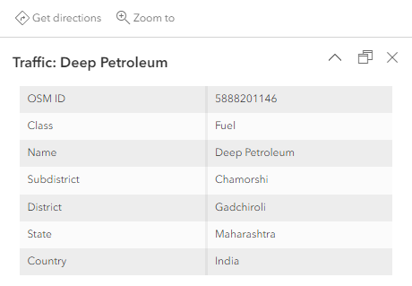
8. Add more detail to the pop-up title by also including the **class** attribute value wrapped in parentheses. This will indicate the general purpose of the point feature.  
     
   Do this by clicking the **Title** item to expand it. You will see a box where the current title syntax can be edited. To the right of that box, click the **{ }** button.  
   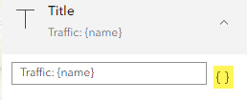
9. Find **Class** in the drop-down menu that appears and click it. **{fclass}** will be added to the end of the title. Wrap the value in parentheses like so: **({fclass})**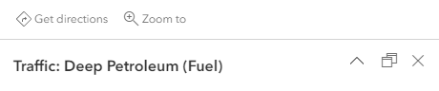
10. Considering the **name** and **class** attributes are displayed in the title, we can remove them from the main pop-up body. Still in the **Pop-ups** pane, below **Title**, click **Fields list** to expand it.
11. Click the **X** button next to **Class** and **Name**.  
    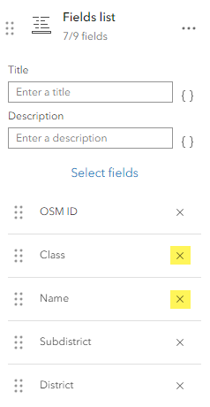  
      
    Both attributes are now removed from the table portion of the pop-up.  
    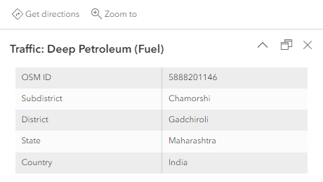
12. The current map contains so many points it is difficult to make sense of what you are viewing when at a small map scale.  
    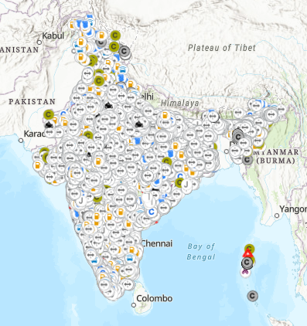
13. This can be addressed with the aggregation technique called clustering. In the right-side menu, open the **Aggregation** pane, toggle **Enable aggregation** on, and select **Clustering**.  
    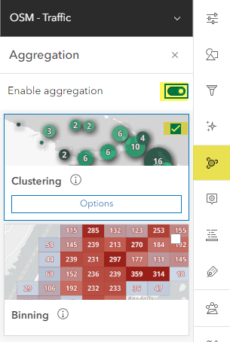
14. The point data is now displayed as clusters. At the center of each cluster symbol is a value indicating how many individual points are contained within the cluster. Double-clicking a cluster symbol will cause the map to zoom in to the extent of that cluster and re-aggregate the visible point features (if necessary).  
    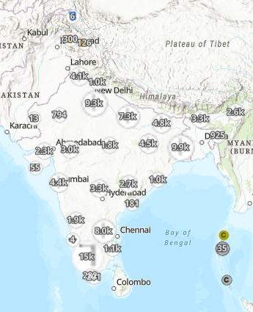
15. The default symbols are difficult to view due to the light basemap and white font for the cluster values. Click **Options** under **Clustering** to open up additional settings.
16. Toggle on **override cluster symbol**. Change the symbol color to something with good contrast such as orange.  
    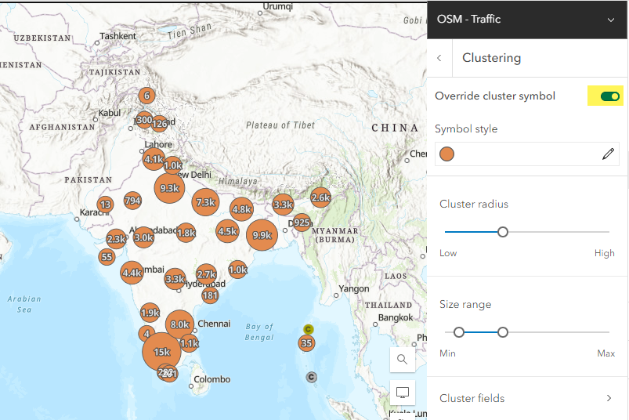
17. Save the map.
18. In the left-side menu, click **… More 🡪 Create app**. Select **Dashboards** in the menu that appears.
19. On the **Create new dashboard** window, provide a title, tags, and summary for the dashboard.
20. In the upper-left corner of the dashboard map, hover over the more options button and click the **Configure** (gear) button.  
    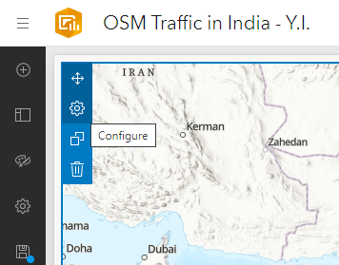
21. There are a lot of different types of point features on display and it is not always obvious from the symbol what a point might represent. Adding a legend to the map could help out in this regard. In the **Settings**, toggle on **Legend**. Afterwards, click **Done**.
22. A togglable legend will now appear in the upper-right corner of the dashboard map.  
    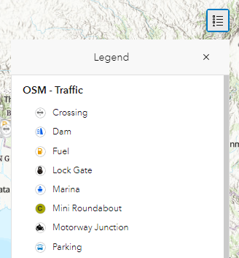
23. Next, you will add a pie chart to the dashboard. It will be used to display the top types of traffic features displayed on the map.  
      
    In the left-side menu, click **Add element**. Add a **pie chart** element to the left side of the map.  
    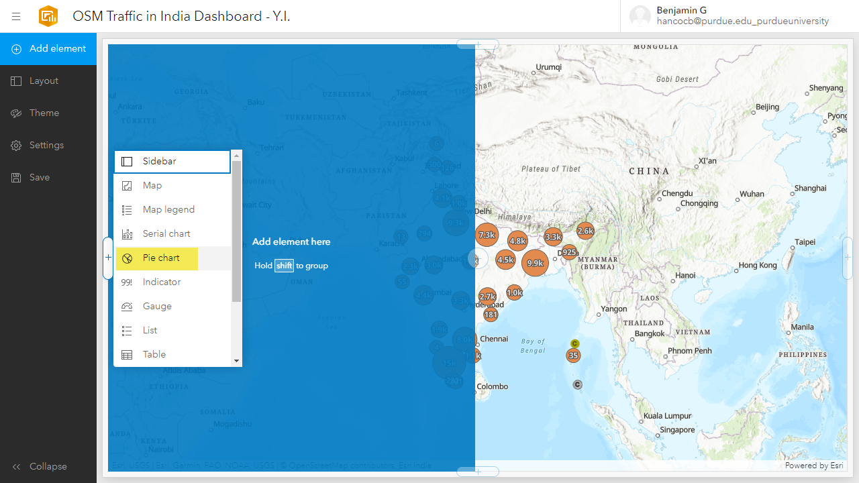
24. On the **Select a layer** window, select **OSM – Traffic**.
25. On the **Pie chart** window, change the **Category field** to **Feature Class**. This is the **fclass** attribute that was added to the pop-up titles previously. Due to the large number of classes, the pie chart is initially challenging to view.  
    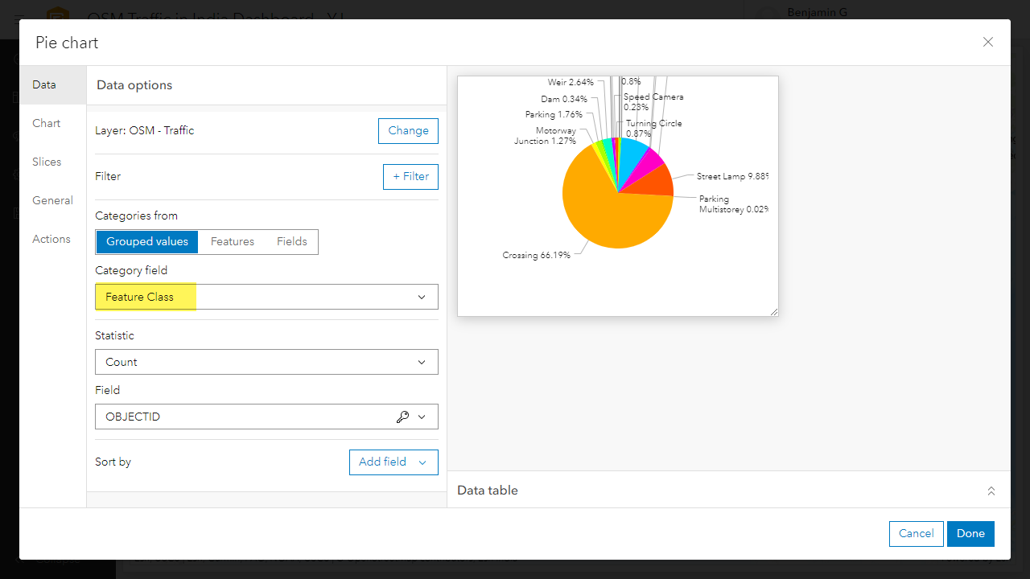
26. Switch to the **Slices** tab on the left-side of the **Pie chart** window. The **Grouping (%)** field can be used to establish a threshold % for the pie chart slices. If a slice is below the threshold, it will not be included in the pie chart.  
      
    Change the **Grouping (%)** to **1**. This will remove all slices below 1% from the pie chart.  
    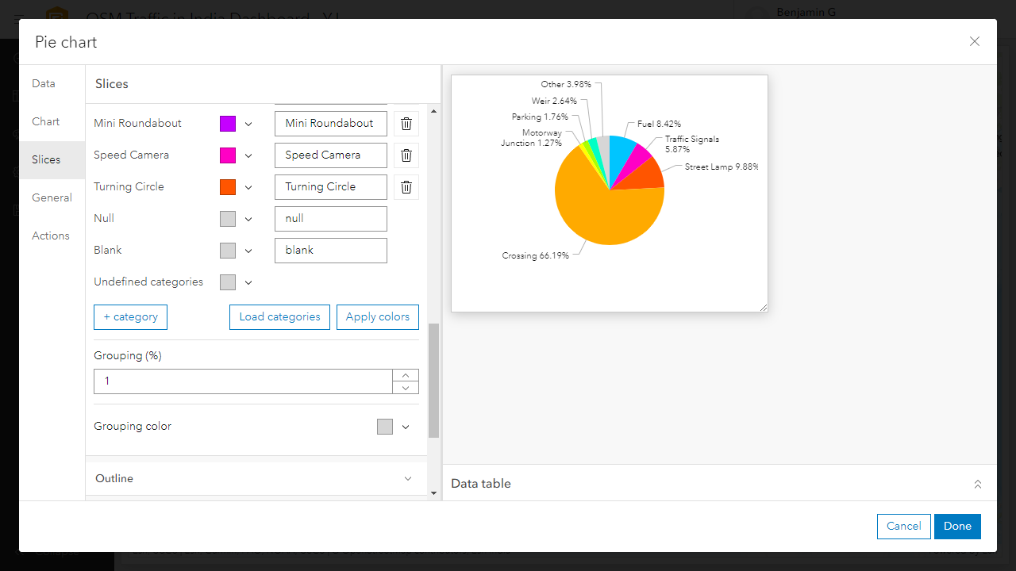
27. Switch to the **General** tab on the left-side of the **Pie chart** window. Here the pie chart title, description, background color, and text color can be changed.
    1. Enter **OSM Classes** as the pie chart **title**.
    2. For the **description**, enter: Class slices less than 1% were dropped from the chart.
28. Click **Done**. Save the dashboard.  
    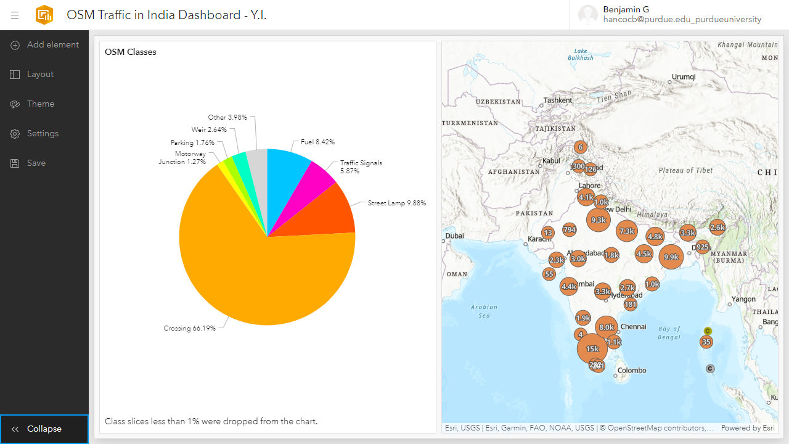
29. On your own, add another dashboard element.